1. **Launch one ec2 using Amazon Linux 2 image and add script in user data to install Apache.**

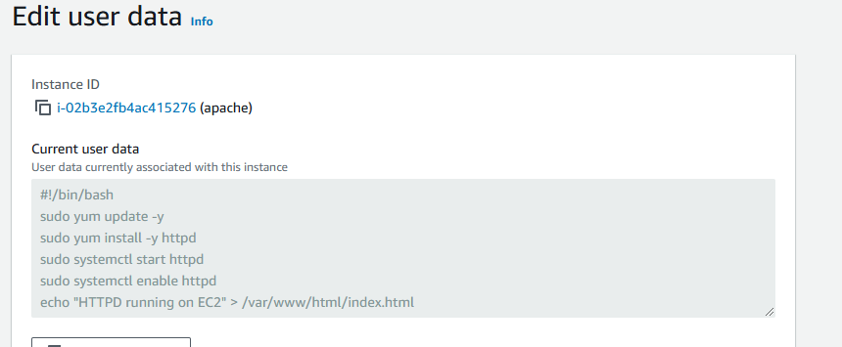

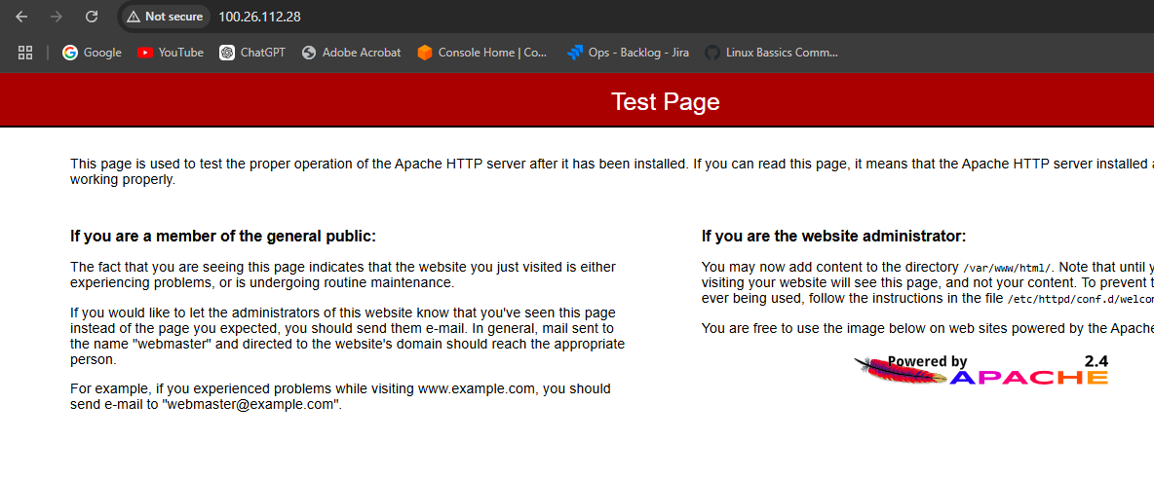

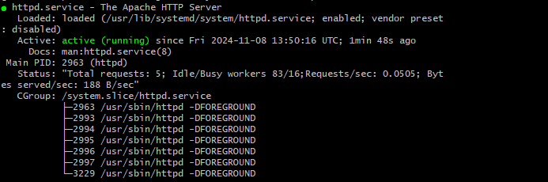

1. **Launch one ec2 using Ubuntu image and add script in user data to install Nginx.**

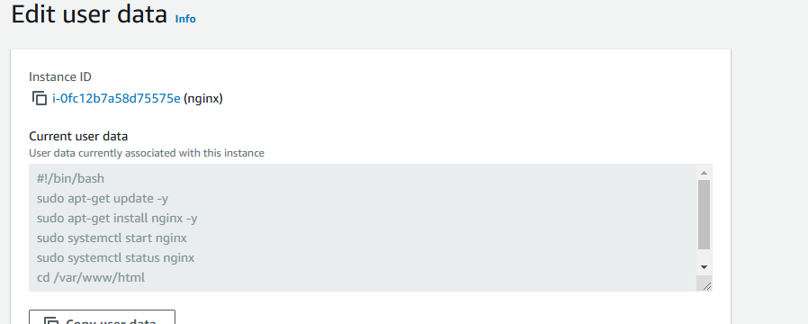

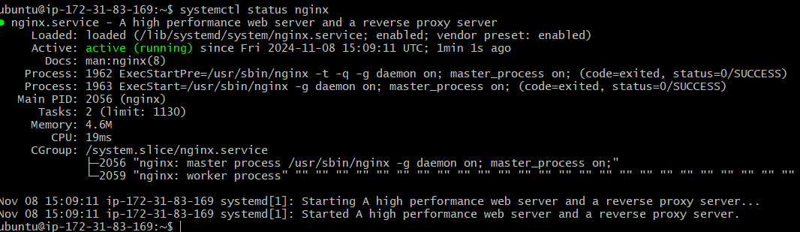

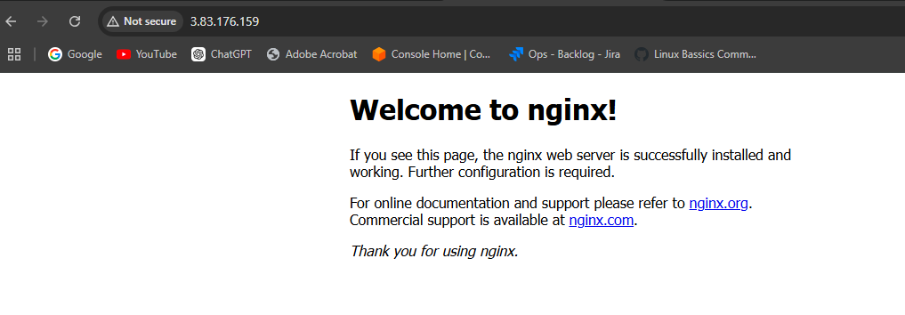

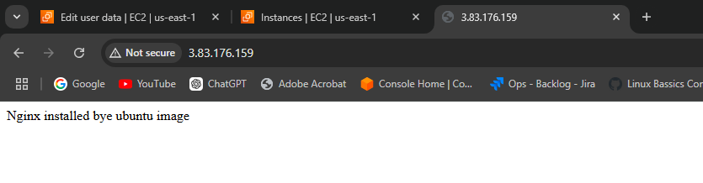

1. **Launch one windows server and install tomcat in windows.**

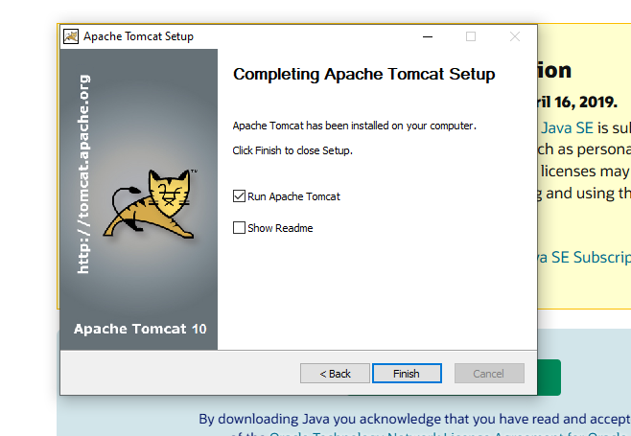

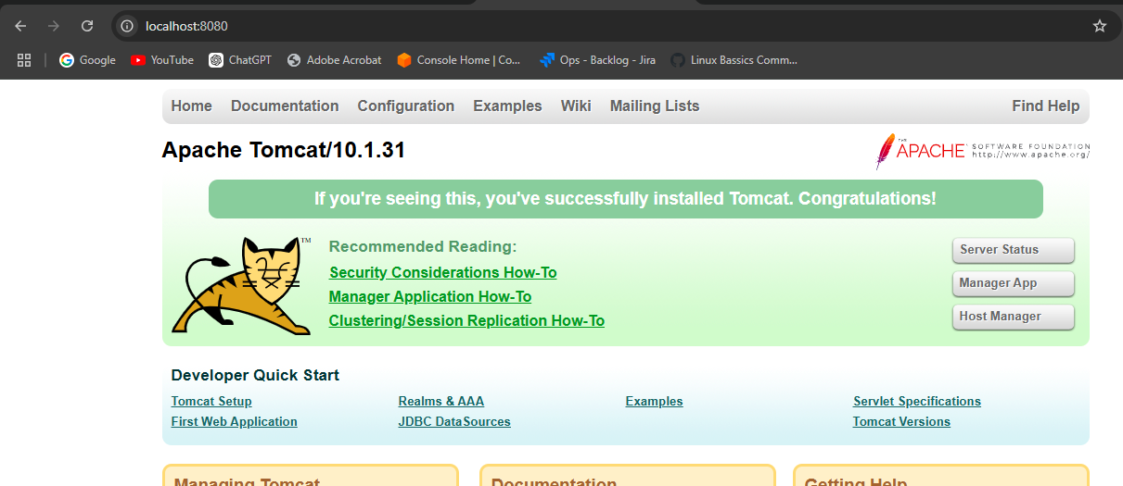

1. **Take snapshot of the instane created in Task 1.**

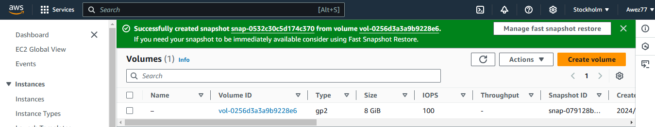

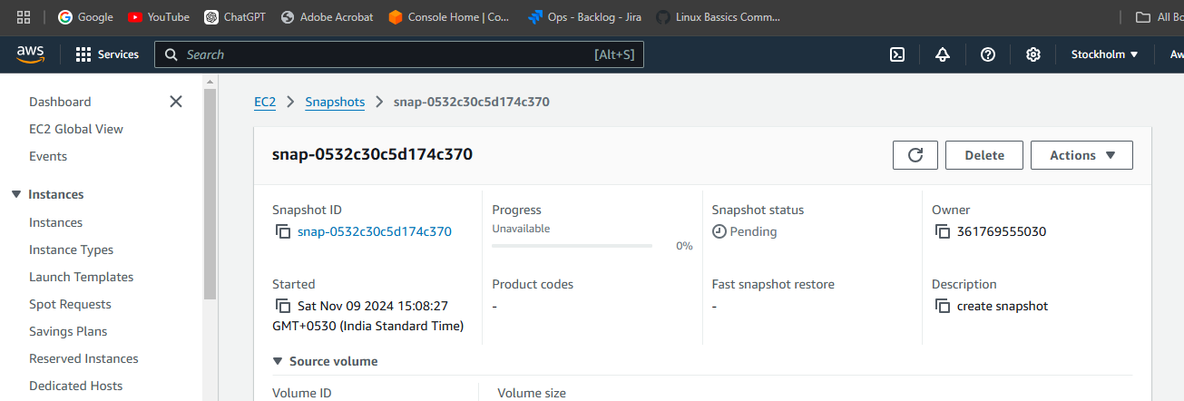

1. **Assign password less authentication for ec2 created on Task 2.**

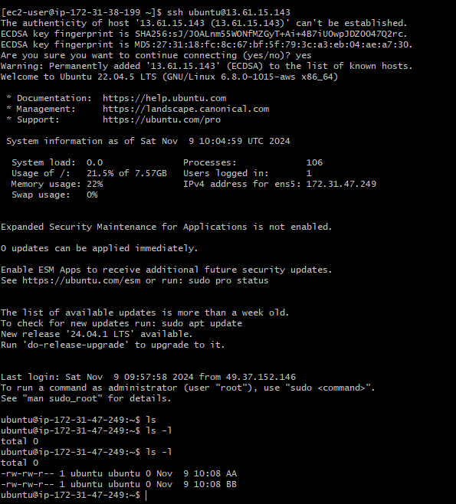

1. **Launch any ec2 using spot purchasing option.**

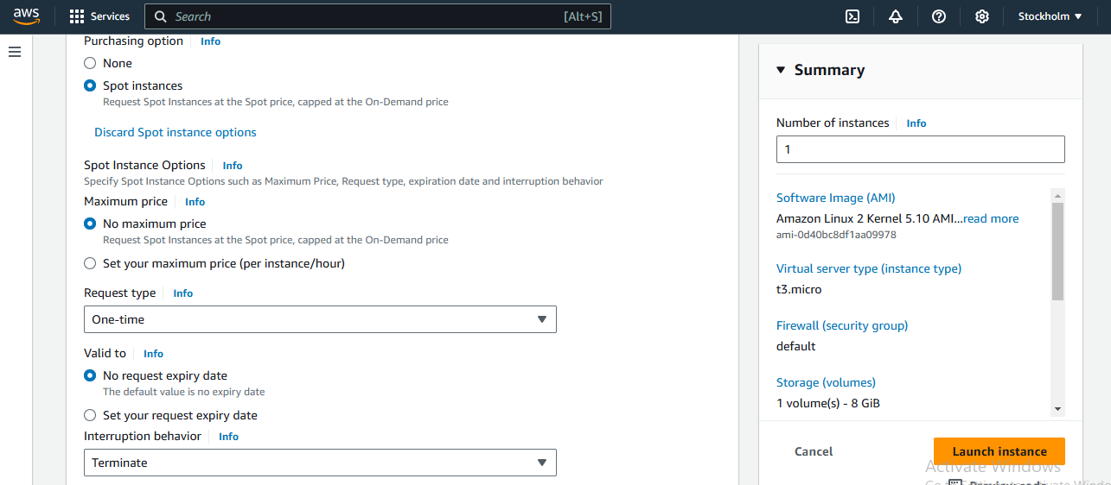

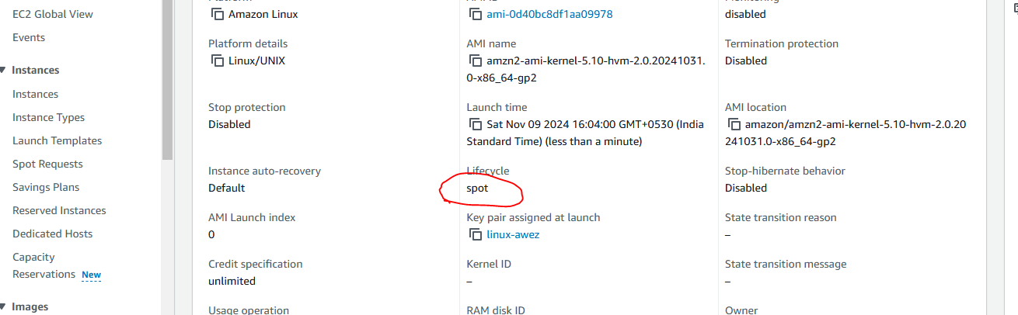

1. **Enable Termination policy on ec2 created in Task 2.**

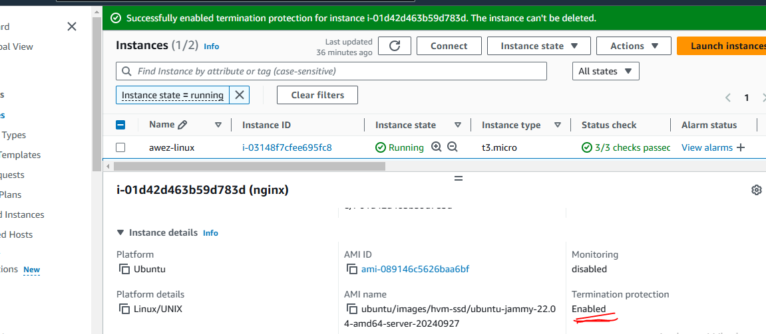

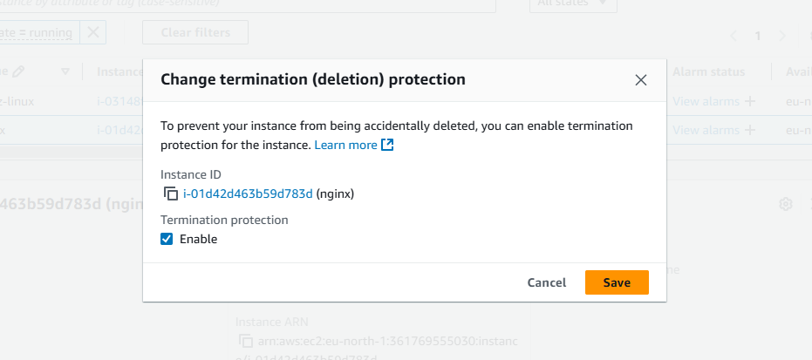

**8) Launch one ec2 using Aws CLI.**

**9) Launch one azure VM using ubuntu image.**

**10) Launch one azure VM using Azure CLI.**